**Proposed**

**JASC.PH**

**JASC.PH HAIR ACCESSORIES ONLINE ORDERING SYSTEM**

**Submitted by:**

Allard Kehn D. Legaspi

Christian D. Villaveza

Jimuel D. Salosa

Renzo A. Cabral

Cecile G. Baral

**Table of Contents**

**Introduction**

Company profile

* 1. Tables
     1. List of tables
     2. List of Figures

**Purpose of the object**

**Intended audience**

**Scope and limitation**

**Diagrams**

* + 1. Use case
    2. Context
    3. DFD
    4. ERD

**Development Methodology**

**Hardware and Software needed**

**Screenshot of the system**

**User manual**

**Summary**

**Conclusion**

**Recommendation**

**Contents**

1. **Introduction**

This story follows a young entrepreneur who started a business making unique and handmade hair accessories. Her passion for crafting beautiful pieces blossomed into a thriving online store. Her creations range from elegant headbands to whimsical hair clips, and each piece is carefully designed and crafted with love. As her business grows, she finds joy in knowing that her accessories bring a touch of style and happiness to people's lives.

1. **Purpose of the project**

The purpose of launching the JASC.ph hair accessories online shop can be multifaceted, incorporating various business and strategic goals. Below are some potential purposes for the project:

* Market Presence and Accessibility.
* E-commerce Expansion.
* Brand Visibility and Recognition.
* Customer Engagement and Experience.
* Responsive to Market Trends.
* Sales and Revenue Growth.

1. **Intended Audience**

* Seller
* Existing costumer
* Future costumer

1. **Scope and Limitations**

**Scope**

* User can view products without login.
* User can search products without login.
* User can go with About Us page by clicking the logo at the top left side.
* User can login, signup and logout.
* User can go in JASC.ph page on other social media platform by clicking the logos in the top right side.
* User can view product, price and each product information.
* User can add to cart the product and choose the color and quantity they want.
* User can update quantity and remove the item in their shopping cart.
* User can check out the item.
* User can set the shipping address for delivery purposes.
* User can view the tracking number, total of the item, tax and shipping details.
* Admin can login and logout.
* Admin can search products without login.
* Admin can go in JASC.ph page on other social media platform by clicking the logos in the top right side.
* Admin can view product, price and each product information.
* Admin can view the user logs information in the Admin Dashboard.
* Admin can view the admin logs information in the Admin Dashboard.
* Admin can add product, add quantity, edit, delete and view in each product.
* Admin can see user information and they can delete that.
* Admin can add another admin and see the information for each admin.
* Admin can view existing order and receive incoming order.
* Admin can see order details/information.
* Admin can accept the order.

**Limitations**

* User can’t choose payment option.
* User can’t track their order.
* User can’t cancel order.
* User can’t edit their personal account like changing password.
* User can’t change contact number for delivery purposes.
* User can’t write feedback/comments for their received orders.
* User can’t chat the admin.
* User don’t have option for return/refund item.
* User can’t rate the product they received.
* Admin can’t track the parcel.
* Admin can’t receive feedback/comments for their received orders.
* Admin can’t print waybill.
* Admin can’t cancel order.

1. **Use Case Diagram**

* **Existing**

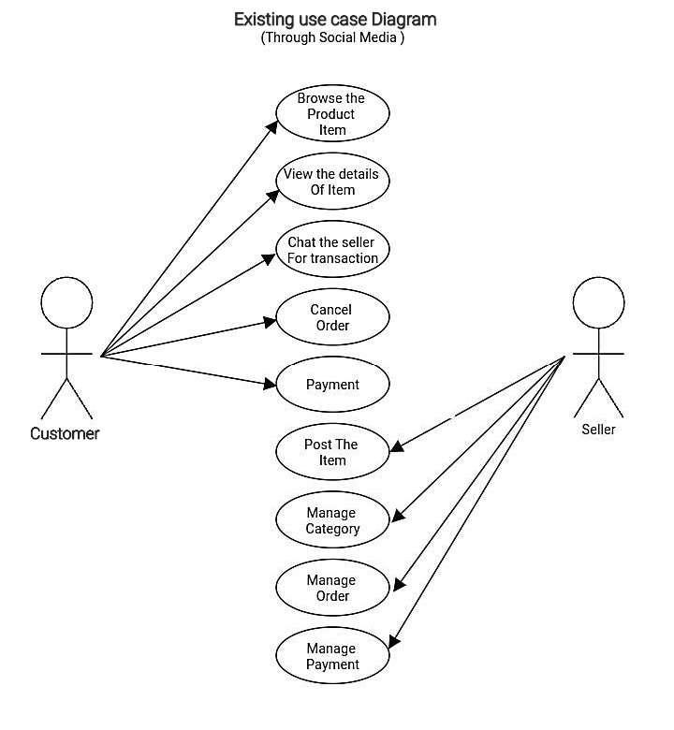

The customer can browse the product through social media. Customers can view all the product details and can chat the seller for payment transaction while the seller can post her items/products, can manage different category like styles and design, can manage orders and also payment transaction.

* **Proposed System**

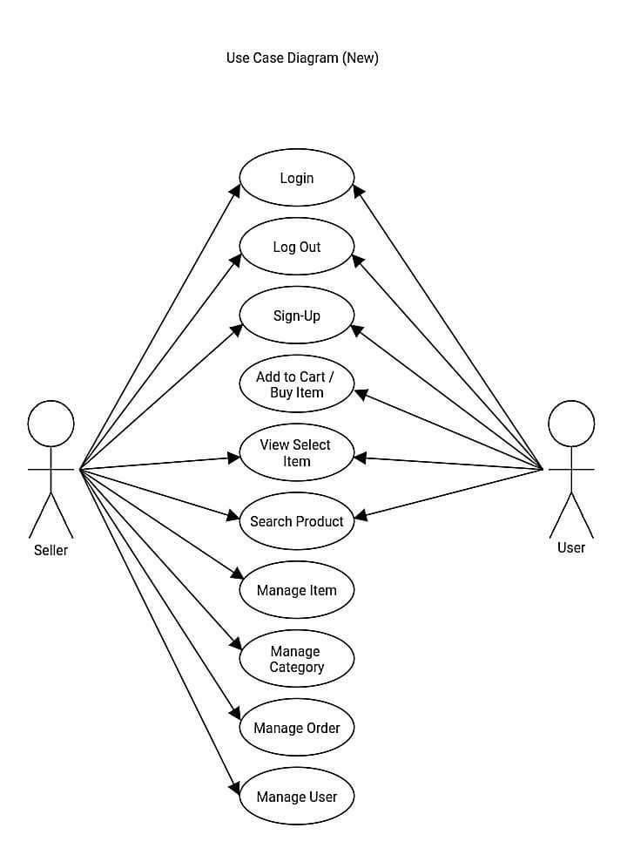

The users can login, logout and register their account. They can also buy an item, set the quantity and place it on their cart or remove. While the admin/seller can also login and logout her account. She is responsible for the managing of category like styles and designs. Can manage the items and incoming orders and also managing user.

1. **Context Diagram**

* **Existing**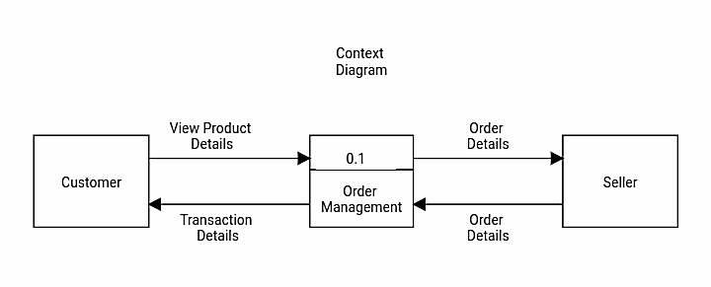

Customer can view the product details, then proceed to order management and the order details will pass to seller. The seller will give the user order details and also transaction details.

* **Proposed System**

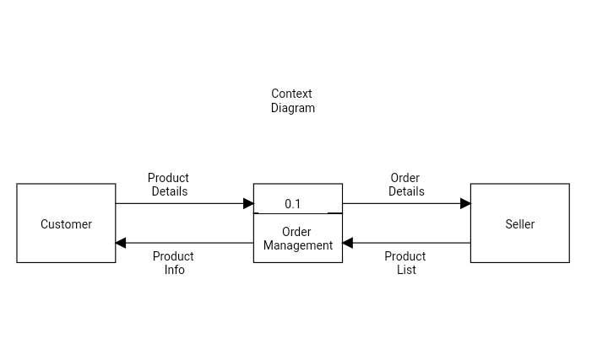

Customer can view the product details, then proceed to order management and the order details will pass to seller. The seller will give the user product list and also product info.

1. **DFD**

* **Existing**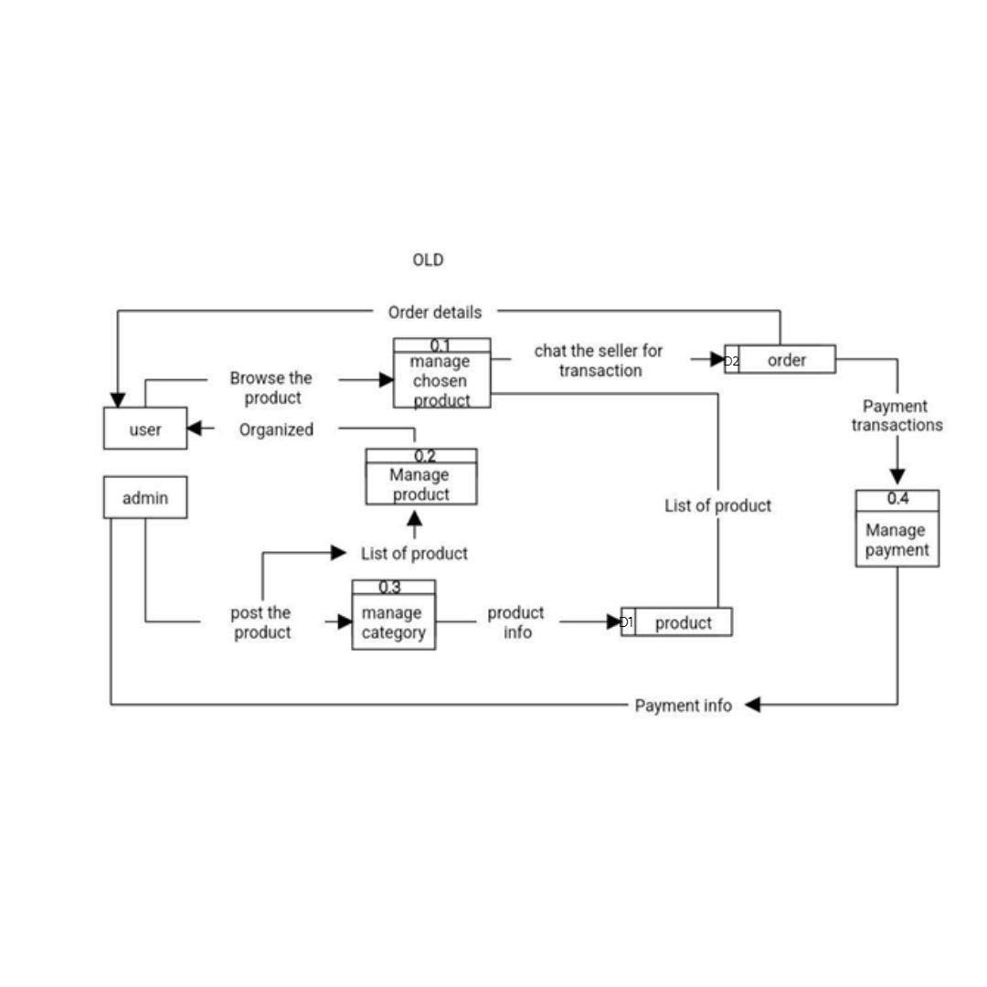

This is the existing DFD of JASC.ph by using social media in selling. As you can see it simple as that. Admin will post the product by managing the category and inputting the product details, and when the user browse the product, he/she will see the product info first and chat the seller about that product. In that case, they also talked about the transaction and payment method.

* **Proposed System**

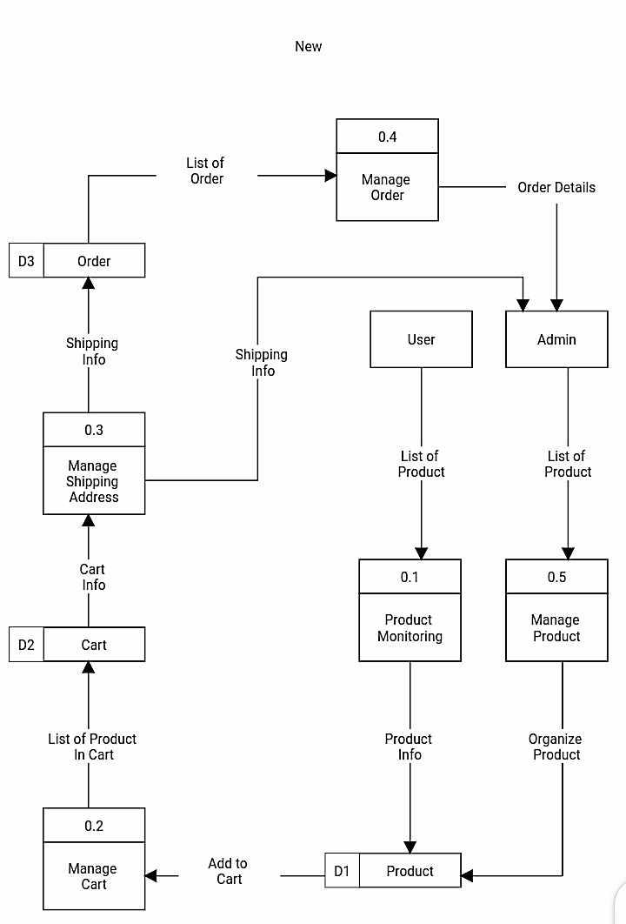

Admin will manage and organize the list of the products while users can monitor their orders info and products list. User can add to cart and admin will manage the cart. admin will also manage the shipping address of the users together with the orders

1. **ERD**

* **Existing**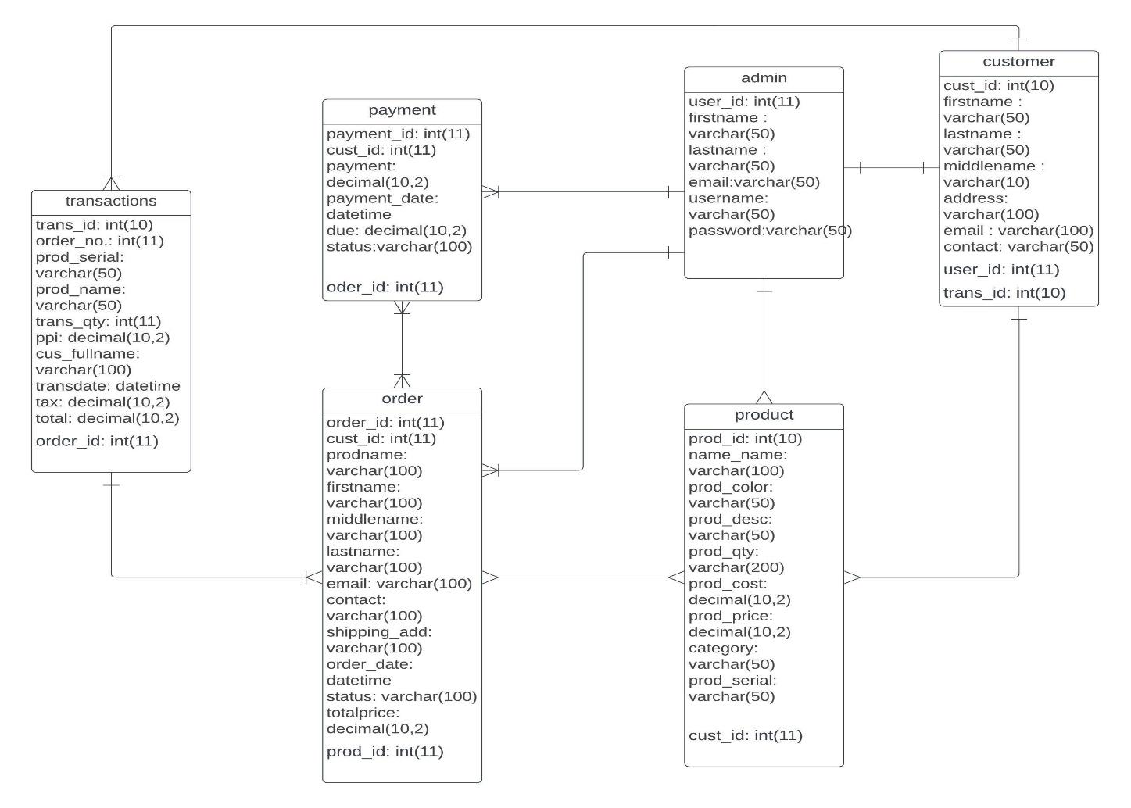

JASC.ph's database architecture is a finely woven tapestry, with each table playing a distinct role in shaping the platform's functionality. The Transactions table choreographs the financial dance, documenting purchase details and linking seamlessly to orders. Meanwhile, the Payment table ensures financial transparency, recording payment specifics and providing a clear trail of transactions. The Order table narrates the journey of each customer's purchase, linking products, customers, and their transactions. Admins, the guardians of the system, find their place in the Admin table, overseeing the seamless functioning of JASC.ph. At the core, the Product table catalogs the details of each accessory, while the Customer table embodies the user base, connecting individuals to transactions and administrators. Together, these tables create the structural backbone, forming a symphony of interconnected narratives that define JASC.ph's dynamic e-commerce landscape.

* **Proposed System**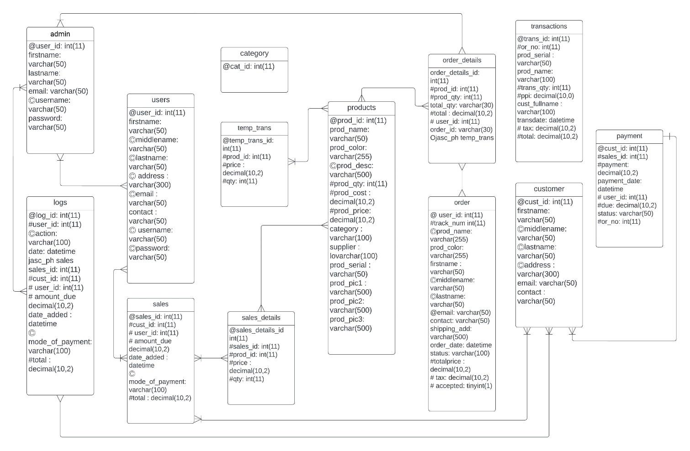

The JASC_ph database comprises several interconnected tables designed to facilitate seamless management of an online retail system. The jasc_ph_users table stores user details, including names, addresses, and contact information. Payment information, such as amount, date, and status, is managed in the jasc_ph_payment table, while the jasc_ph_order_details table records specifics about ordered products. Temporary transactions find their place in the jasc_ph_temp_trans table, and customer information is stored in the jasc_ph_customer table. Transaction actions are logged in the jasc_ph_actions table, sales details in the jasc_ph_sales_details table, and order details in the jasc_ph_order table. Product categorization is handled by the jasc_ph_category table, and system actions are recorded in the jasc_ph_logs table. Sales information, including mode of payment and total amount, is managed by the jasc_ph_sales table, while detailed product information is stored in the jasc_ph_products table. Administrative credentials are stored securely in the jasc_ph_admin table. Together, these tables form a robust database structure catering to various aspects of a comprehensive online retail system.

1. **Development Methodology**

We chose the Agile methodology for developing our hair accessories online shop system due to its inherent flexibility, iterative development approach, and strong emphasis on customer collaboration. This decision aligns with the dynamic nature of the fashion industry, allowing us to quickly adapt to changing trends, prioritize user-centric design, and deliver a feature-rich online shopping experience with a quick time-to-market. The collaborative team environment promoted by Agile ensures effective communication among our cross-functional teams, facilitating seamless coordination and risk mitigation throughout the development process.

1. **Hardware and Software needed**

**Hardware**

| Component | Specification |
| --- | --- |
| Operating System | Windows Server 2008 and later Windows Vista and later Mac OS X 10.6 and later CentOS, Ubuntu, Fedora, Gentoo, Arch, SUSE |
| Random Access Memory (RAM) | At least 8 GB memory card. |
| Random Only Memory (ROM) | 10 GB unused space inside the Hard Drive. |

**Software**

| Component | Specification |
| --- | --- |
| Web Server | Apache,AMPPS, WampServer,  MAMP and XAMPP |
| Web Browser | Such as Mozilla Firefox, Google Chrome, Microsoft Internet Explorer, Apple Safari, and the Opera browser |
| Database Management System (DBMS) | such as MySQL, PostgreSQL, or Microsoft SQL Server, is crucial for managing and storing large volumes of data efficiently. |

1. **Screenshot of the system**

* **User Side**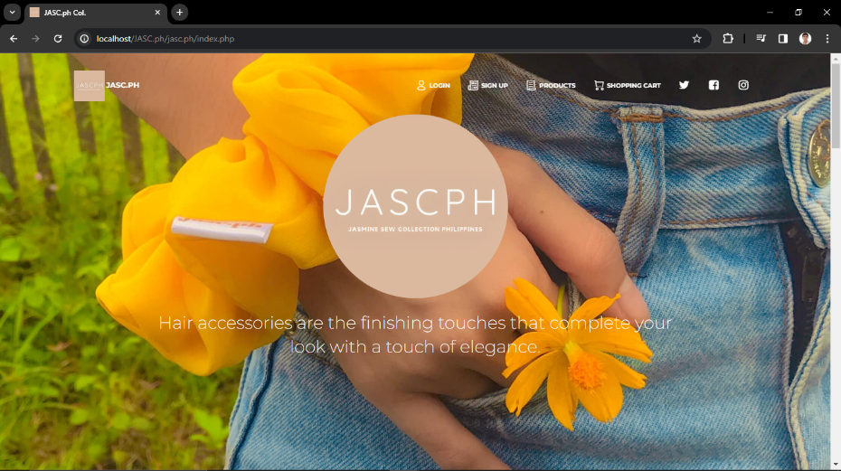
* This is the page for index.

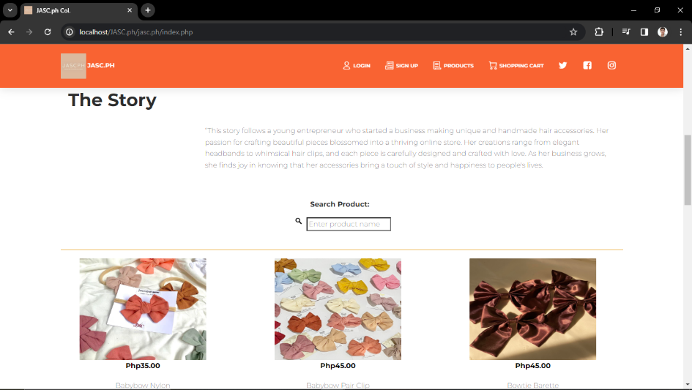

* The Story and Search Bar.

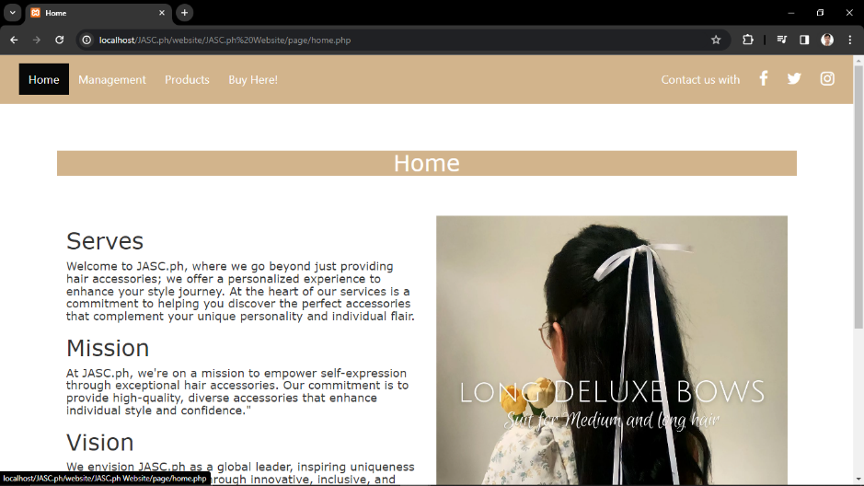

* This is the page for home.

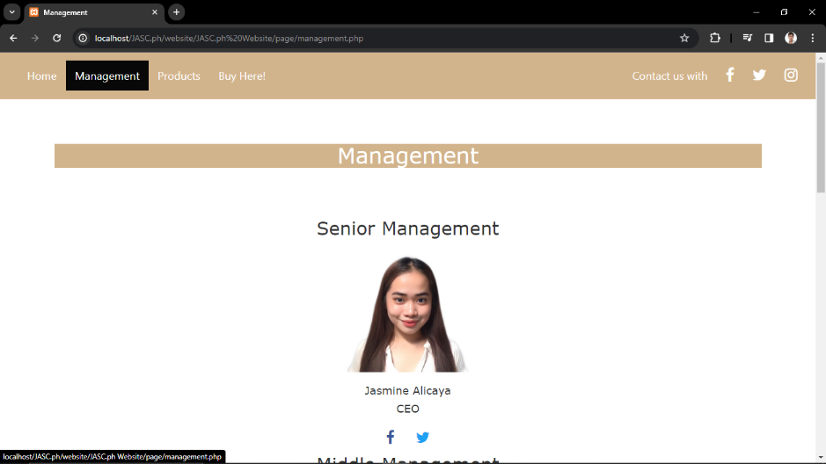

* This is the page for management.

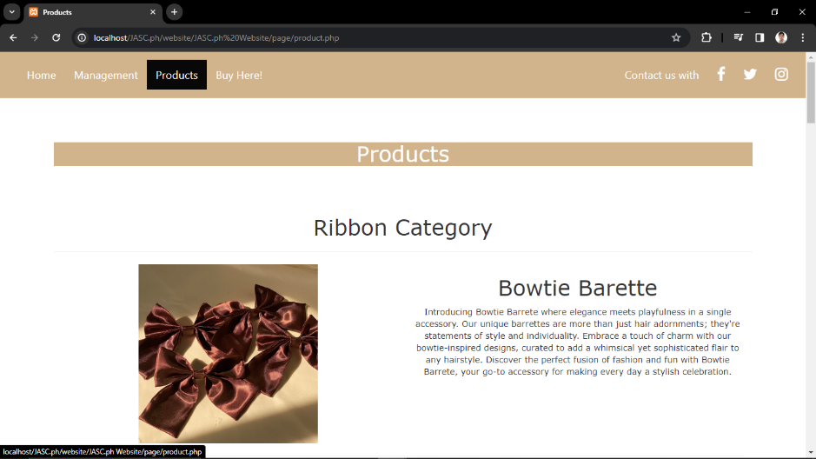

* This is the page for product list.

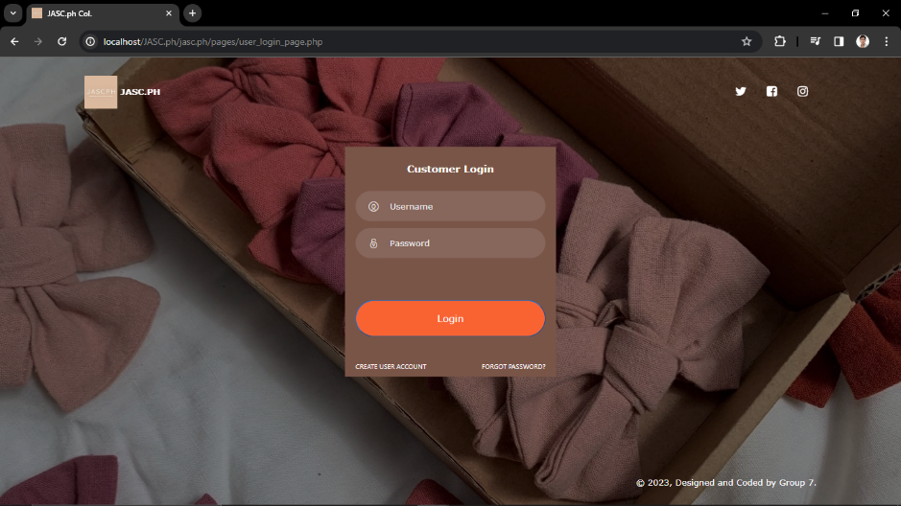

* This is the page for customer login.

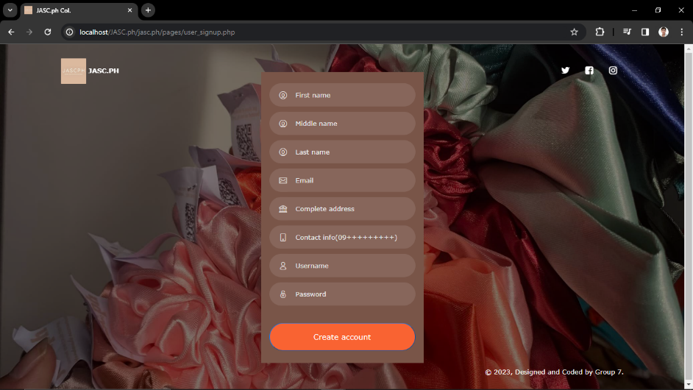

* This is the page for user signup.

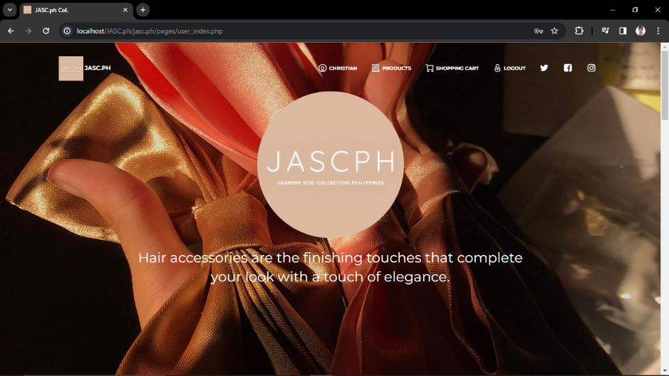

* This is the page for user index.

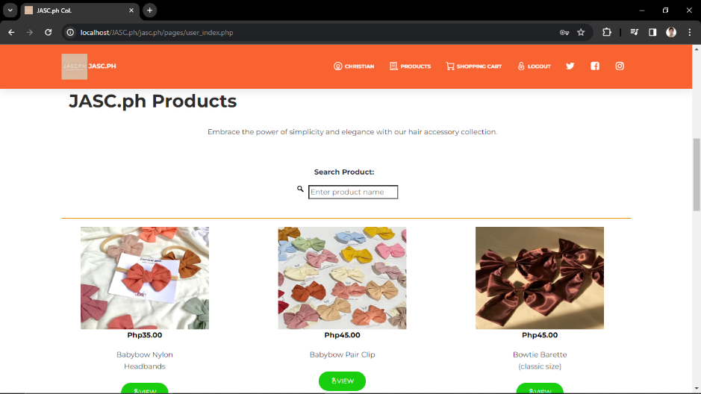

* The Story and Search Bar.

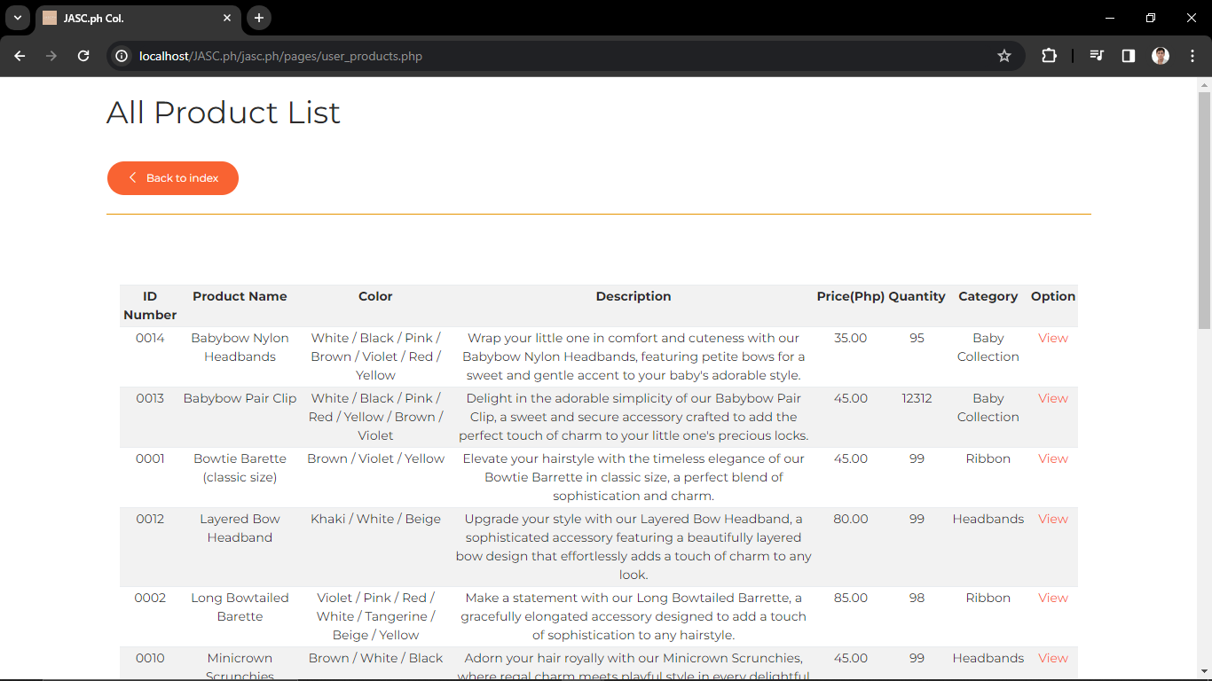

* This is the page for product.

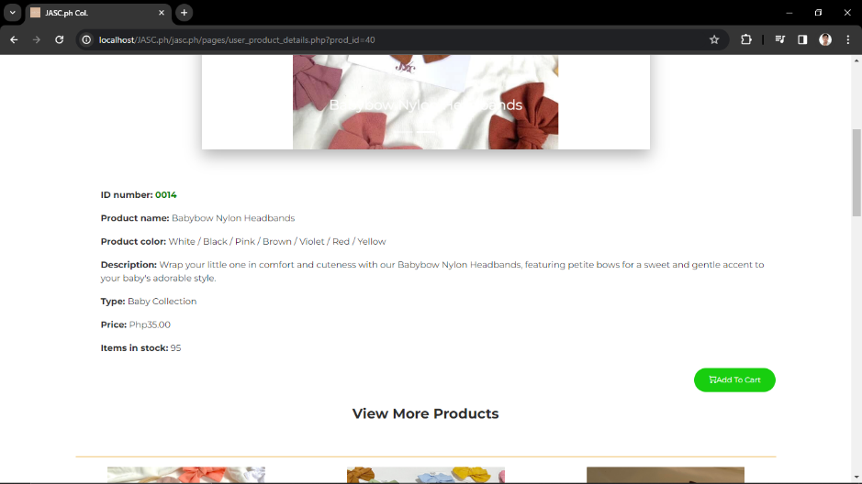

* This is the page for product details.

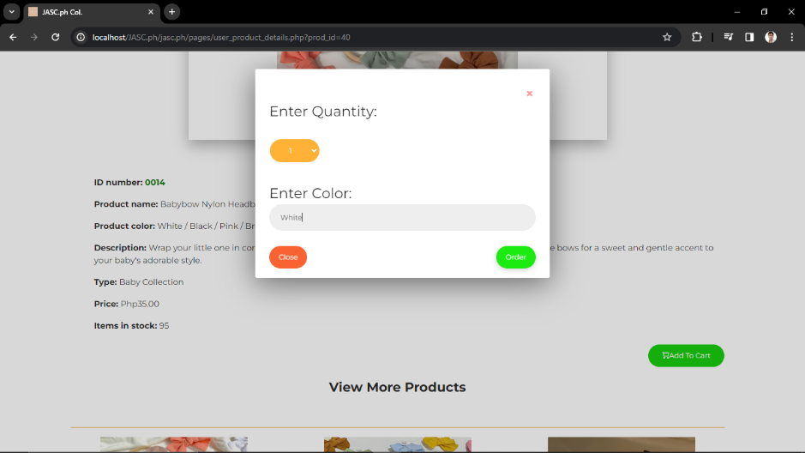

* Inputting quantity and color.

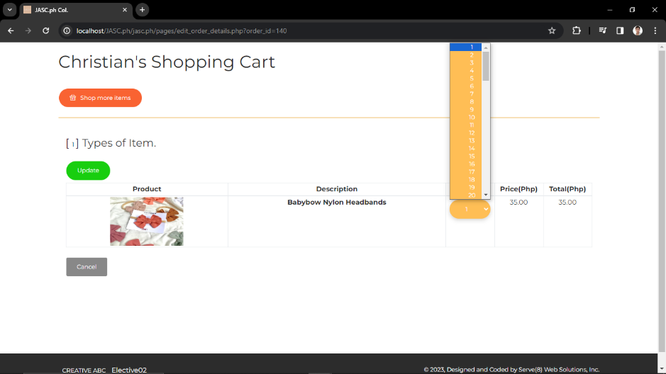

* Edit quantity of product in shopping cart.

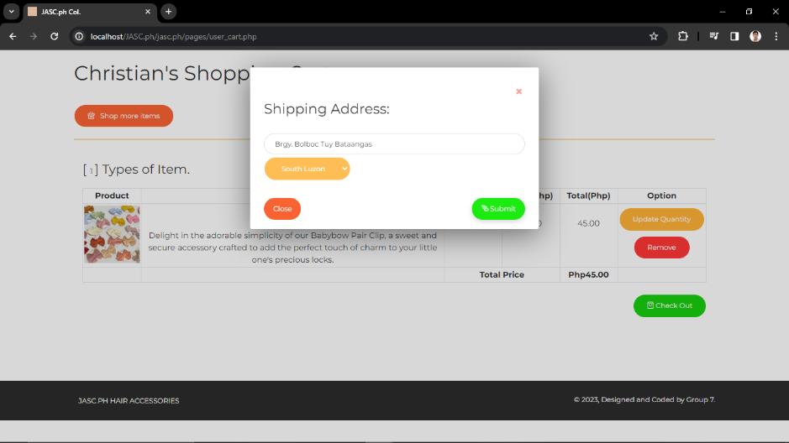

* Inputting shipping details

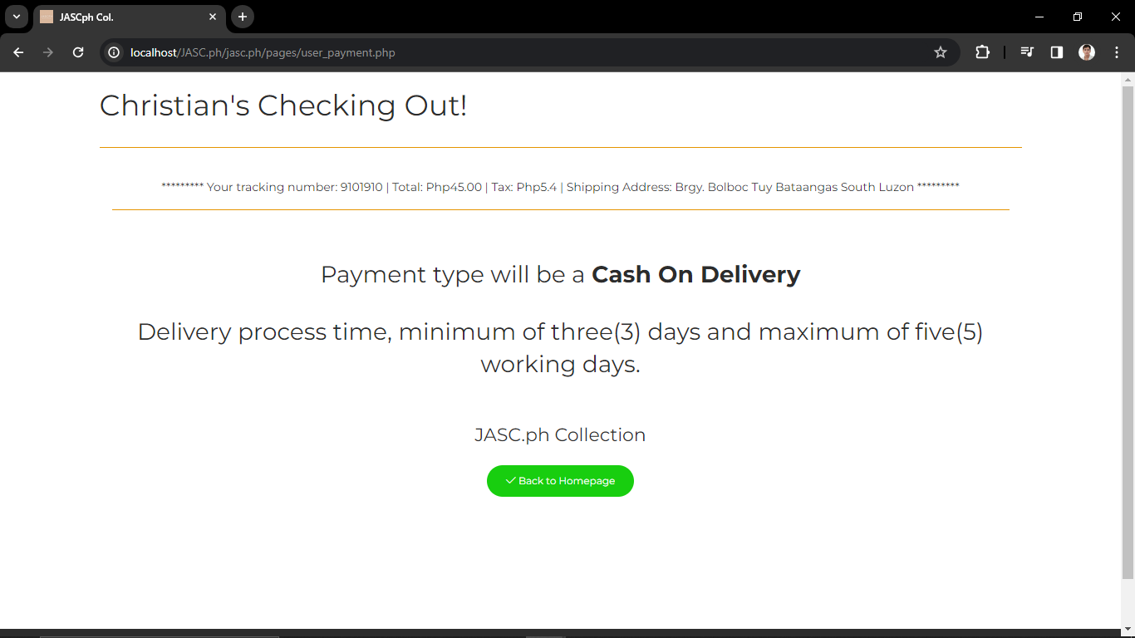

* This is the page when you press the checkout.
* **Admin Side**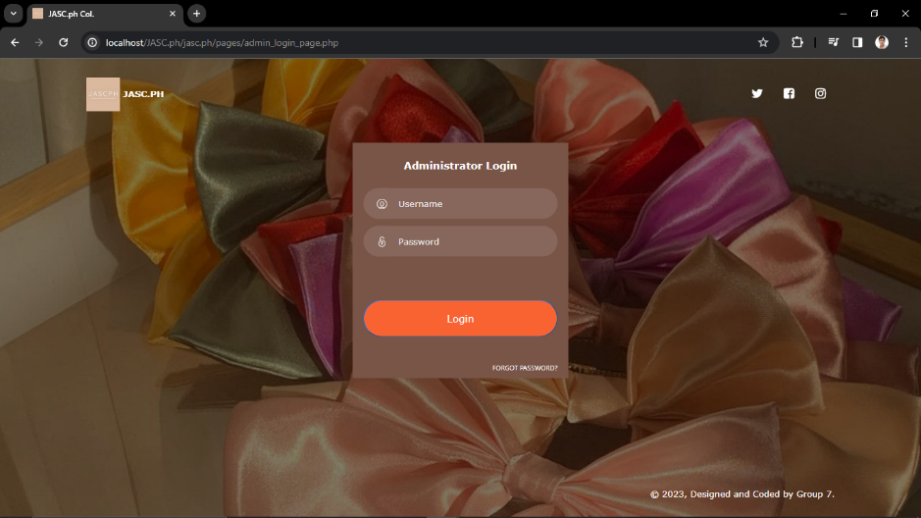
* This is the page for admin login page.

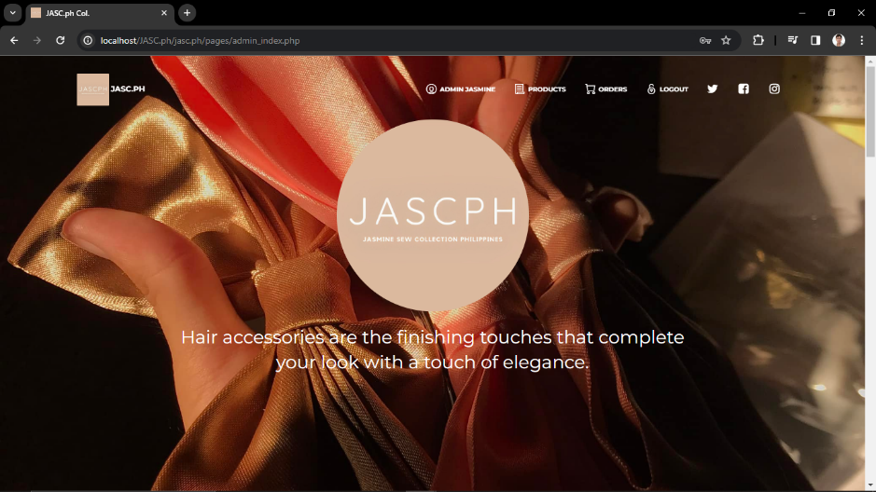

* This is the page for admin index.

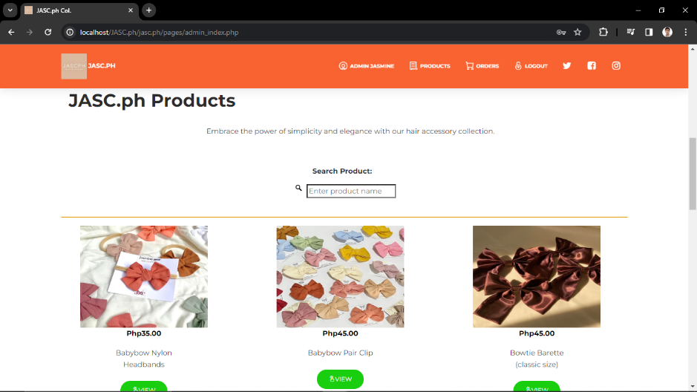

* The Story and Search Bar.

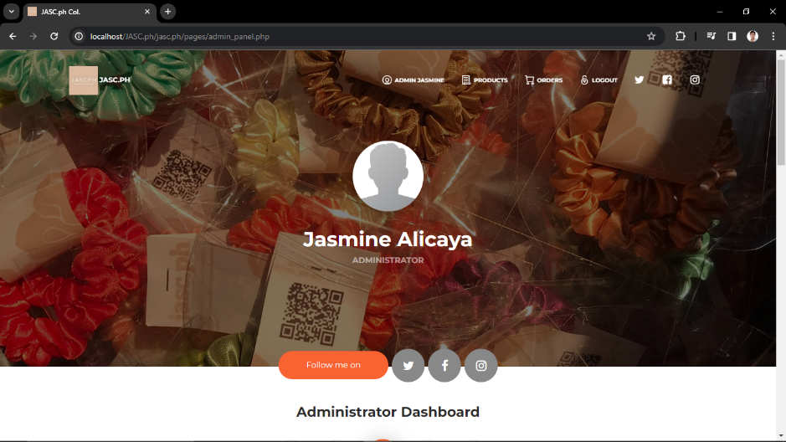

* This is the page for admin panel.

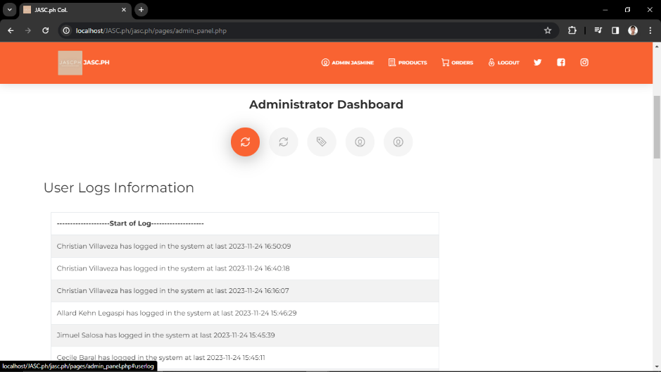

* Tracking user logs information.

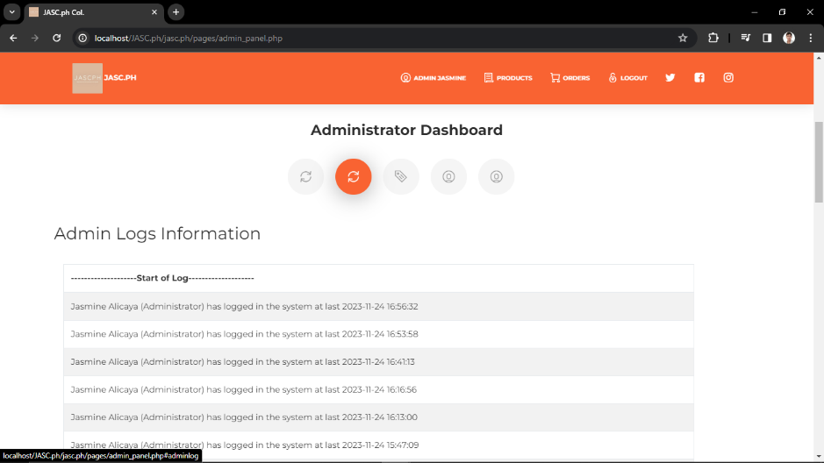

* Tracking admin logs information.

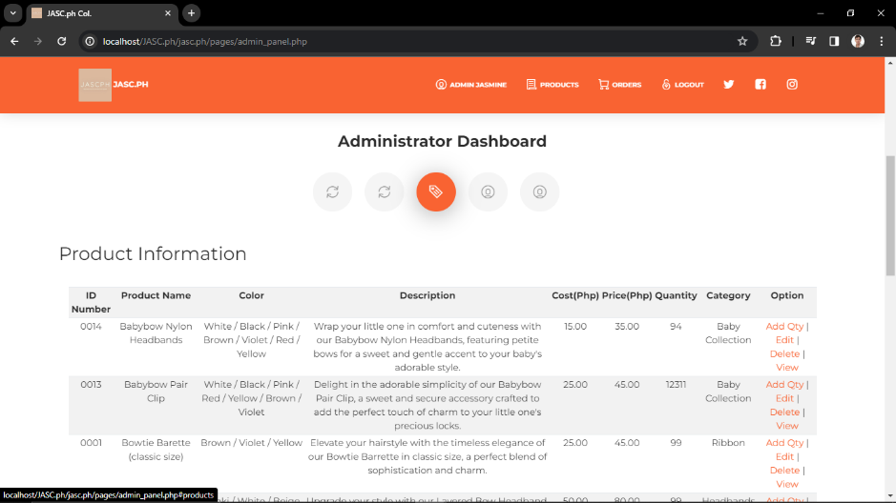

* This is the list of product you added where you can add quantity, edit, delete and view.

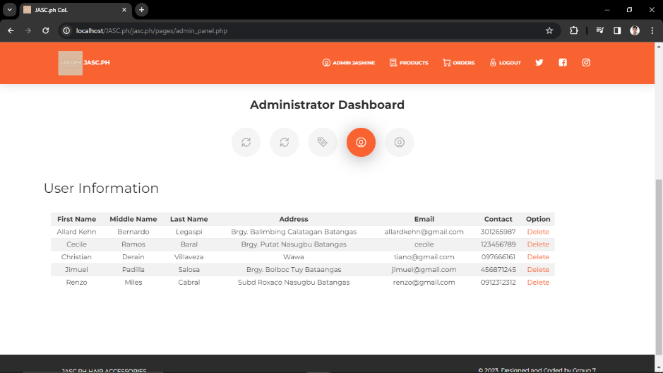

* This is the list of user who has an account in JASC.ph, you can also delete the user if you want.

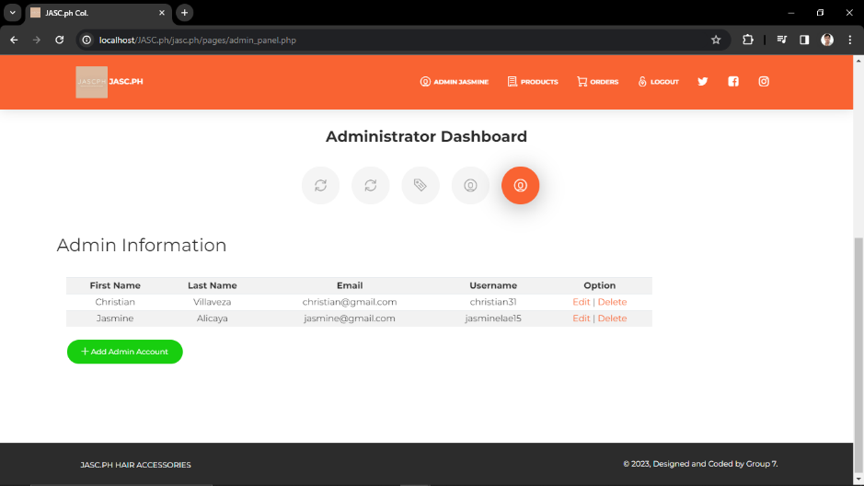

* This is the list of admin who has an account in JASC.ph, you can also edit and delete the admin if you want.

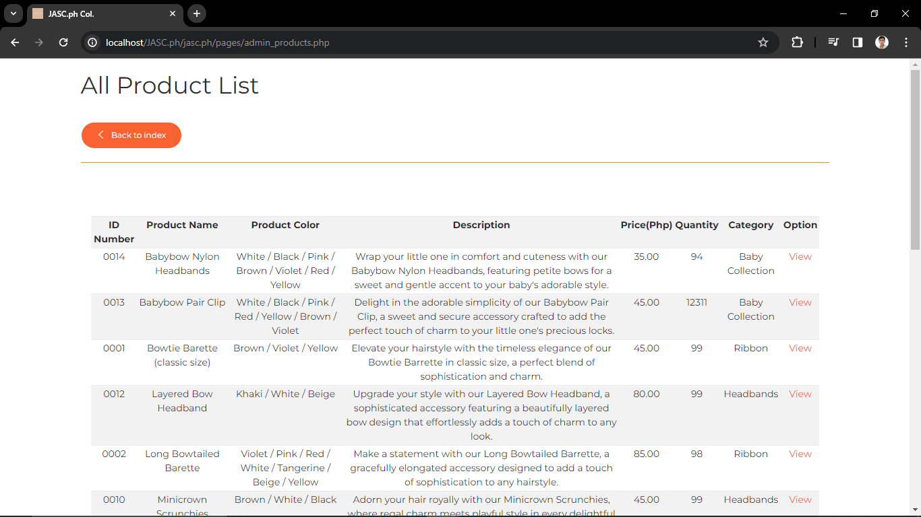

* This is the page for product.

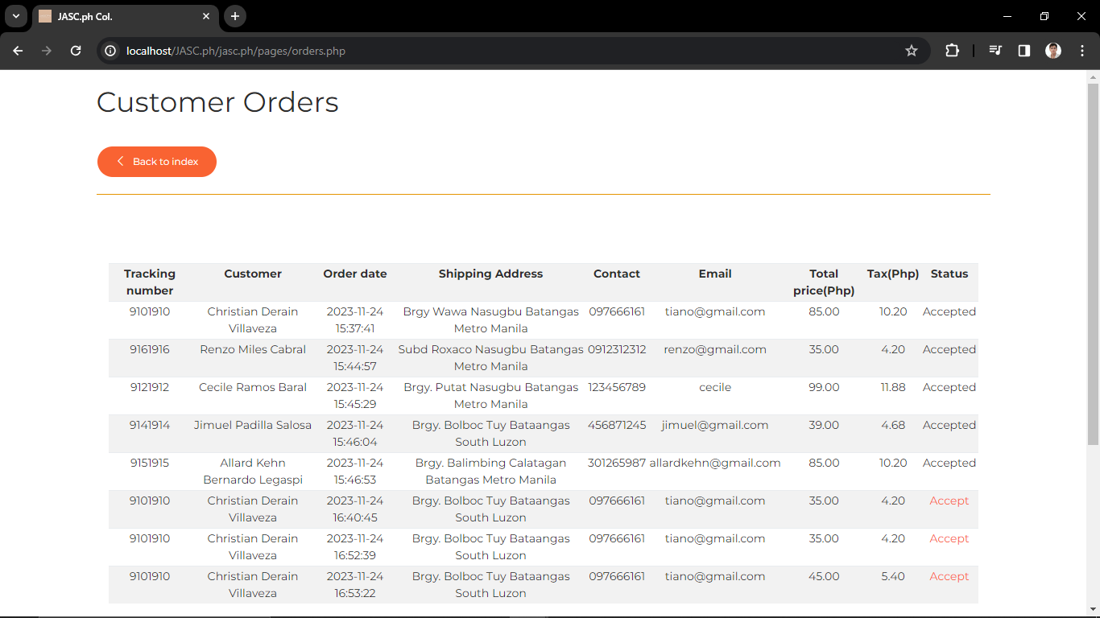

* This is the page customer order.

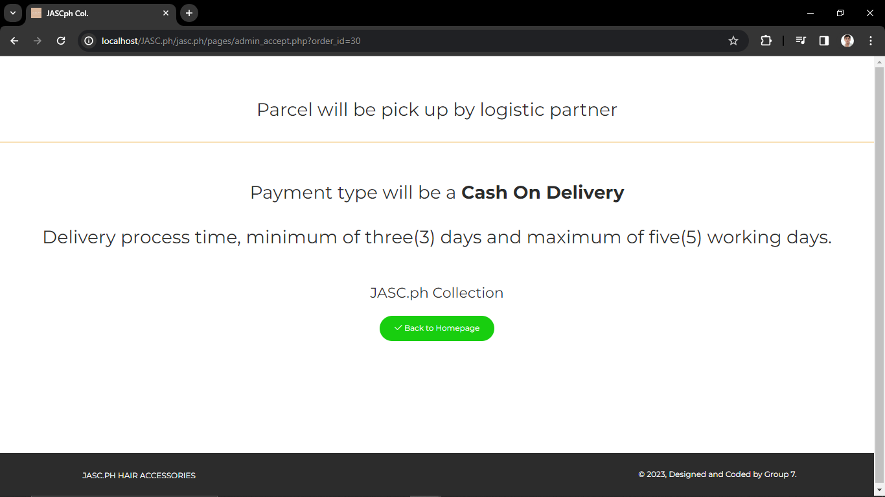

* Confirmation that you accept the order.

1. **User manual**

* **User Side**
* **Step 1.** In this page, you can see the top-navbar including JASC.ph logo, login, signup, products, shopping cart and logos of different social media platform. When you click that logo, you’ll go to the shop page.



* **Step 2.** Scroll down and you’ll see the story or a background of a shop, including the search bar and list of products.



* **Step 3**. When you click the leftt-top navbar at step 1 which is the logo of JASC.ph, you’ll go to the About Us page



* **Step 4**. Click the management and you’ll see the team who are the part of the proposed project system.



* **Step 5.** Click the products and you’ll go to the products available on the shop including the description.

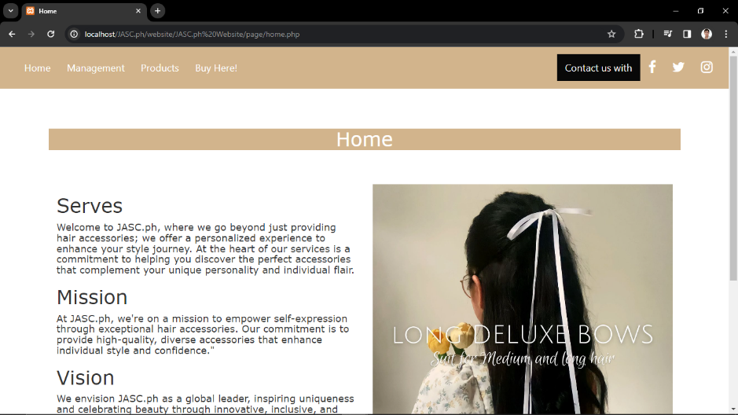

* **Step 6.**  The logos at the right-top navbar is similar at step 1.

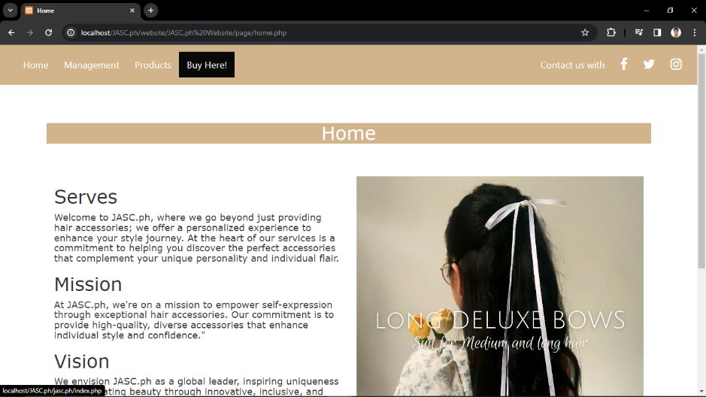

* **Step 7.** Click Buy Here and you’ll back to the index page.



* **Step 8.** Click the login button and you’ll go to the login page. And if you don’t have account you can create by clicking the “CREATE USER ACCOUNT”.



* **Step 9.** This will ask you for your personal details



* **Step 10.** After login, you’ll go to the index.



* **Step 11.** Scroll down and you’ll see the list of available products.



* **Step 12.**  By clicking the products at index page, you’ll go to the All Product List page which include all the description of each products.



* **Step 13.** By clicking the view in All Product List page. You can also see the description of the product you choose to view. In this page, you can also add to cart the item if you want



* **Step 14.** It will ask you for the quantity and the color you want.

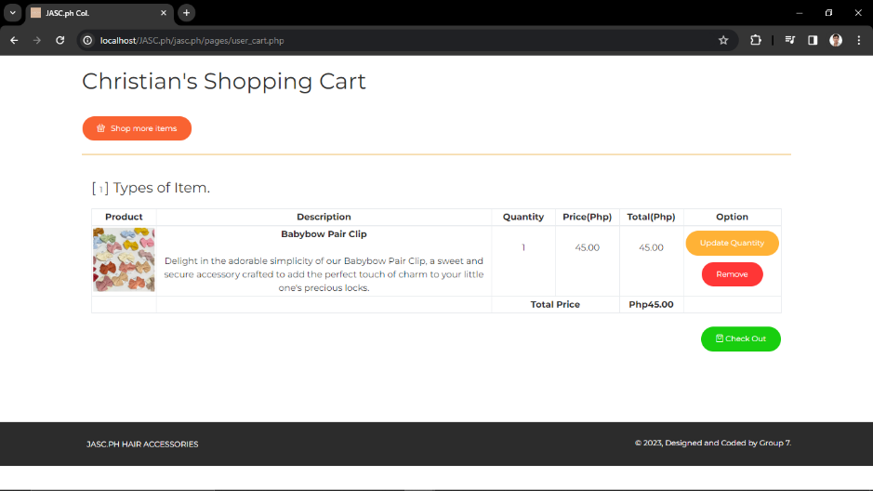

* **Step 15.** This is your shopping cart, you can update the quantity of the product you added, and you can also remove that.



* **Step 16.** By clicking the update button, you can now update the quantity.



* **Step 17.** If you don’t want to update the quantity, you can now click the “Check Out” button and it will ask you for shipping address.



* **Step 18.** By clicking the “Submit” button, you are finally ordered. In this page, you can see the details of your parcel. By clicking the “Back to the Homepage” button, you’ll go back to the index
* **Admin Side**
* **Step 1.** By logging in the admin, you’ll ask first for your username and password.

*(Note that in this page, you can’t create admin account.)*



* **Step 2.** After logging in, you’ll go to the admin index.



* **Step 3.**  Scroll down and you’ll see the list of products, you can also search the product of what you looking for.



* **Step 4.** By clicking the admin at the top-navbar, you’ll go to the admin dashboard/panel.



* **Step 5.** Scroll down a little bit and you can access the User Logs Information.



* **Step 6.** You can also access Admin Logs Information.



* **Step 7.** You can also access Product Information. You can add quantity, edit, delete and view the product.

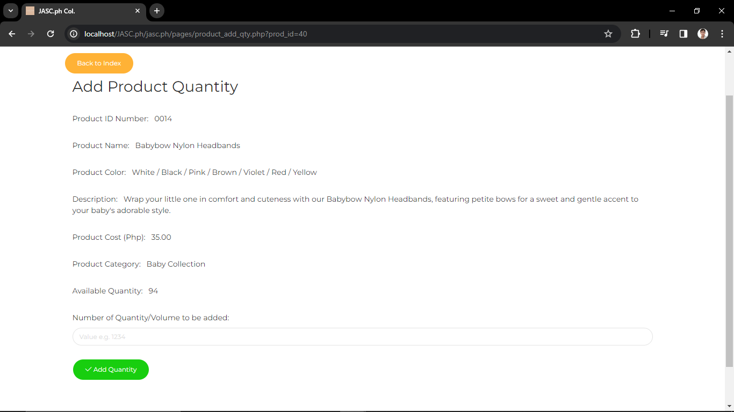

* **Step 8.** Adding the product quantity.

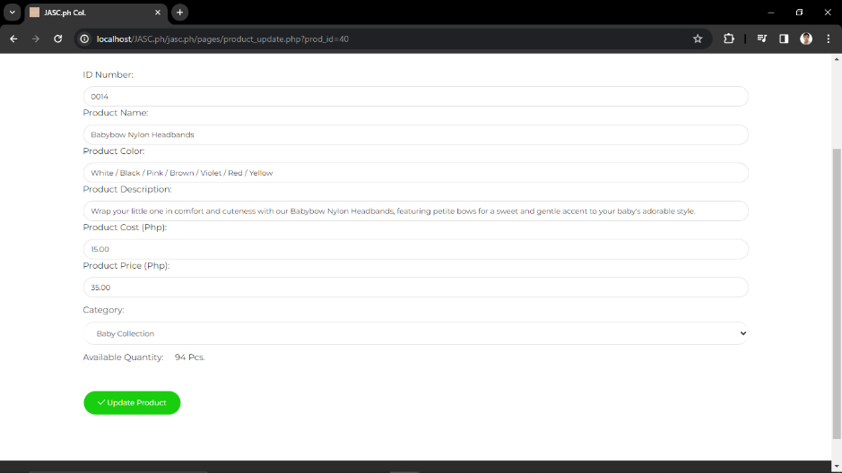

* **Step 9.**  Updating the product.

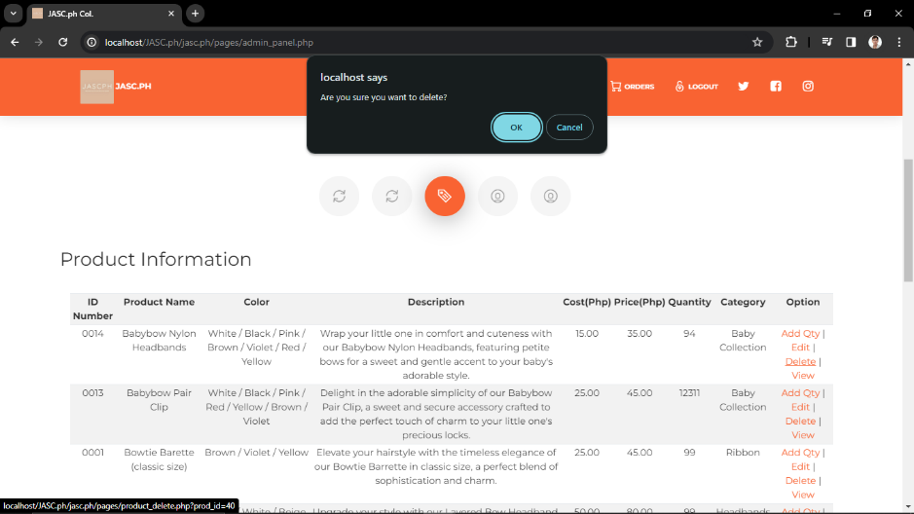

* **Step 10.**  Deleting the product.



* **Step 11.** You can also access the User Information, you can also delete it if you want.



* **Step 12.** You can also access the Admin Information, you can also edit and delete it if you want.

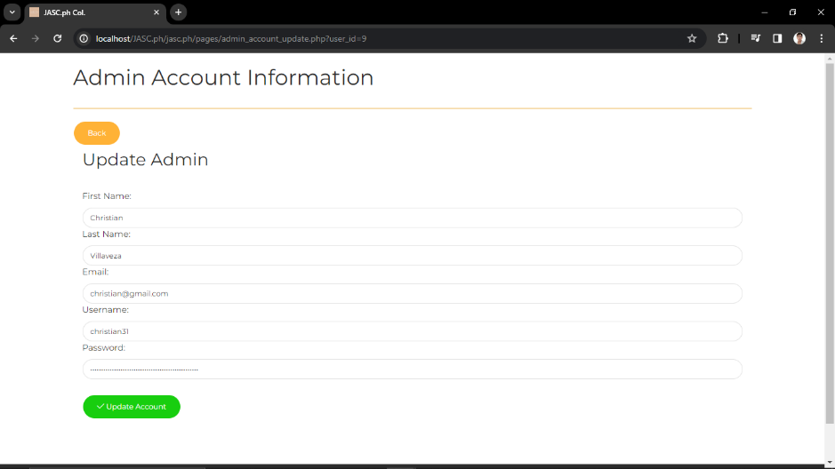

* **Step 13.** Update Account Information for Admin.



* **Step 14.** By clicking the products at index page, you’ll go to the All Product List page which include all the description of each products.



* **Step 15.** By clicking the orders at the index page, you’ll see all the list of orders.

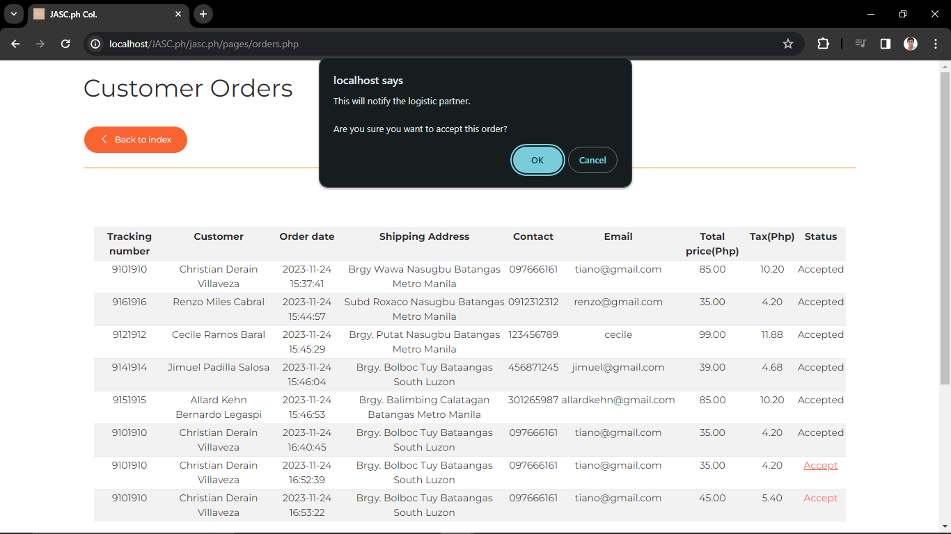

* **Step 15.**  Confirmation that you accept the order.  
    
  *(Note that it will automatically disappear once the courier pick up the parcel)*



* **Step 16.** Finally!You have an parcel to deliver!

1. **Summary**

In summary, the development of a hair accessories online shop system represents a strategic move to meet the evolving demands of a diverse and dynamic market. Guided by the Agile methodology, the project aims to create a flexible, adaptive, and customer-centric platform that swiftly responds to fashion trends and provides an engaging shopping experience. The intended audience, spanning fashion enthusiasts, event planners, gift shoppers, and a global customer base, underscores the need for a versatile and user-friendly online shop.

The Agile approach facilitates quick time-to-market for the latest trends, iterative improvements based on user feedback, and a collaborative team environment. The project's success hinges on understanding and catering to the unique preferences of the audience. Overall, the goal is to establish a vibrant online destination that not only showcases trendy hair accessories but also offers a seamless, innovative, and enjoyable online shopping experience for customers of all backgrounds and styles.

1. **Conclusion**

In conclusion, the development of a hair accessories online shop system is driven by the central goal of creating a versatile and customer-oriented platform that seamlessly integrates with the fast-paced trends in the fashion industry. By adopting the Agile methodology, we aim to ensure adaptability to evolving market demands, quick responsiveness to shifting styles, and continuous enhancement. The overarching objective is to establish a dynamic online destination that not only showcases the latest hair accessory trends but also provides an engaging and personalized shopping experience for a diverse and discerning audience.

Our vision for success revolves around creating an aesthetically pleasing and user-friendly interface, fostering a collaborative team environment, and delivering a platform that caters to the distinct needs of various customer segments. Through this project, we aspire to carve a niche in the competitive e-commerce landscape, offering a reliable and innovative online space where individuals can effortlessly explore, select, and purchase trendy hair accessories that resonate with their unique styles and preferences.

1. **Recommendation**

In enhancing the design of the JASC.ph system, it's crucial to incorporate features that not only streamline the user experience but also foster customer engagement and satisfaction. Firstly, implementing a robust customer feedback system can provide valuable insights into customer preferences and areas for improvement. Introducing a rating and review section for each product allows customers to share their experiences, helping future buyers make informed decisions. This feature not only builds trust but also establishes a sense of community around the brand.

Additionally, integrating a comprehensive order tracking system is essential to keep customers informed about the status and location of their purchases. Real-time updates on the shipping progress instill confidence in customers, providing a transparent and reliable shopping experience. Enabling customers to choose their preferred payment method ensures convenience, catering to various preferences. Whether it's credit/debit cards, digital wallets, or other online payment options, a diverse range accommodates a broader customer base.

Moreover, considering the absence of a physical shop location, a prominent display of the online shop's contact information and customer support details should be incorporated into the system. This builds trust and assures customers that assistance is readily available. Lastly, adding a messaging feature for customers to communicate directly with the admin fosters a personalized touch, enabling quick responses to inquiries, addressing concerns, and strengthening the connection between JASC.ph and its customers. The design enhancements should revolve around these customer-centric features to elevate the overall shopping experience and establish JASC.ph as a user-friendly and customer-oriented platform.

1. **CV**



Christian Derain Villaveza

Brgy. Wawa Nasugbu, Batangas | 0975-924-3167 villavezachristian31@gmail.com

To obtain a position that will enable me to use my educational background and ability to work well with people, and to enhance my skills and personality.

**EDUCATION**

2023 – Present: Batangas State University

Bachelor of Science in Information Technology

Bucana, Nasugbu, Batangas

2019 – 2021: Pantalan Senior High School

Senior High School

Pantalan, Nasugbu, Batangas

2015 – 2019: Dr. Crisogono B. Ermita Sr. Memorial National High School

High School to Junior High School

Roxaco Landing Subdivision, Barangay Pantalan, Nasugbu, Batangas

2009 – 2015: Wawa Elementary School

Elementary

Wawa, Nasugbu, Batangas

**SKILLS**

**•** Good communication

• Integrity and Confidentiality

• Multitasking skills

• Attention to detail

• Cultural awareness skills

• Speed and Agility

• Positive attitude

• Problem-solving and conflict management skills

• Knowledge of food safety and hygiene

**PERSONAL INFORMATION**

Status: Single

Gender: Male

Age: 21 years old

Height: 170 cm

Weight: 75 kg

Birthdate: October 31, 2002

**CHARACTER REFERENCES**

Chatline Villaveza

Team Leader | HCL 09360968389

I hereby certify that the above information is true and correct to the best of my knowledge.

CHRISTIAN DERAIN VILLAVEZA

Cecile Gatdula Baral

Brgy. Butucan Nasugbu, Batangas | 0905-781-2801

cecilegatdulabaral@gmail.com

To obtain a position that will allow me to use my educational background and ability to work well with people, and to enhance my skills and personality.

**EDUCATION**

2023-Present: Batangas State University

Bachelor of Science in Information Technology

Bucana, Nasugbu Batangas

2019-2021:Pantalan Senior High School

TVL-ICT graduate

Brgy. Pantalan Nasugbu Batangas

2015-2019: Malapad na Bato National High School

High School to Junior High School

Brgy. Malapad na Bato, Nasugbu Batangas

2009-2015: Panuca Elementary School

Elementary

Brgy. Butucan Nasugbu Batangas

**SKILLS**

* Good communication
* Hardworking
* Multitasking skills
* Knowledge in Technology
* Trustworthy
* Creative
* Problem Solving Skills
* Cheerful and Polite

**PERSONAL INFORMATION**

Status: Single

Gender: Female

Age: 21 years old

Height: 159

Weight: 45 kg

I hereby certify that the above information is true and correct to the best of my knowledge.

CECILE GATDULA BARAL

Allard Kehn Dimaala Legaspi

Brgy. Real Calatagan, Batangas | 0992-903-5478

legaspikehn@gmail.com

To obtain a position that will enable me to use my educational background and ability to work well with people, and to enhance my skills and personality.

**EDUCATION**

2023 – Present: Batangas State University

Bachelor of Science in Information Technology

Bucana, Nasugbu, Batangas

2019 – 2021: Enzotech Senior High School

Senior High School

Gulod, Calatagan, Batangas

2015 – 2019: Lucsuhin National High School

High School to Junior High School

Lucsuhin Calatagan, Batangas

2009 – 2015: Enrique Zobel Elementary School

Elementary

Real, Calatagan, Batangas

**SKILLS**

• Good communication

• Time Management

• Multitasking skills

• Technology

• Listening skills

• Speed and Agility

• Positive attitude

• Computer skills

• Video Editing skills

**PERSONAL INFORMATION**

Status: Single

Gender: Male

Age: 22 years old

Height: 170 cm

Weight: 63 kg

Birthdate: August 10, 2001

**CHARACTER REFERENCES**

Chatline Legaspi

Team Member | HCL

09929035478

I hereby certify that the above information is true and correct to the best of my knowledge.

ALLARD KEHN DIMAALA LEGASPI

Jimuel Delos Reyes Salosa

Brgy. Sabang Tuy, Batangas | 0936-135-7266 daasalosa@gmail.com

To obtain a position that will enable me to use my educational background and ability to work well with people, and to enhance my skills and personality.

**EDUCATION**

2023 – Present: Batangas State University

Bachelor of Science in Information Technology

Bucana, Nasugbu, Batangas

2019 – 2021: Tuy Senior High School

Senior High School

Tuy, Batangas

2015 – 2019: Bilaran National High School

High School to Junior High School

Bilaran Nasugbu Batangas

2009 – 2015: Eulogio G. Cerrado Elementary School

Elementary

Sabang Centro

**SKILLS**

● Good communication

● Integrity and Confidentiality

● Attention to detail

● Adaptability

● Time management

● Positive attitude

● Problem-solving and conflict management skills

**PERSONAL INFORMATION**

Status: Single

Gender: Male

Age: 20 years old

Height: 165 cm

Weight: 64 kg

Birthdate: August 21, 2003

**CHARACTER REFERENCES**

Jimuel D. Salosa

Team Member | HCL 09361357265

I hereby certify that the above information is true and correct to the best of my knowledge.

JIMUEL DELOS REYES SALOSA

Renzo A. Cabral

Brgy Roxaco, Nasugbu Batangas| 0936-555-1620

[cabralrenzo16@gmail.com](mailto:cabralrenzo16@gmail.com)

To obtain a position that will enable me to use my educational background and ability to work well with people and to enhance my skils and personality.

**EDUCATION**

2023 – Present: Batangas State University

Bachelor of Science in Information Technology

Bucana, Nasugbu, Batangas

2019 – 2021: Pantalan Senior High School

Senior High School

Pantalan, Nasugbu, Batangas

2015 – 2019: Adelaido A. Bayot Memorial School

Junior High School

JP Laurel ST. Nasugbu, Batangas

2009 – 2015: Adelaido A. Bayot Memorial School

Elementary

JP Laurel ST. Nasugbu, Batangas

**SKILLS**

* Active Listening Skills
* Computer Skills
* Communication Skills
* Management Skills
* Time Management Skills
* Problem Solving Skills
* Interpersonal Skills

**PERSONAL INFORMATION**

Status: Single

Gender: Male

Age: 22 years old

Height: 169 cm

Weight: 54 kg

Birthdate: April 20, 2002

**CHARACTER REFERENCES**

Lani Adona

09363532232

I hereby certify that the above information is true and correct to the best of my knowledge.

RENZO ADONA CABRAL

1. **Interview**

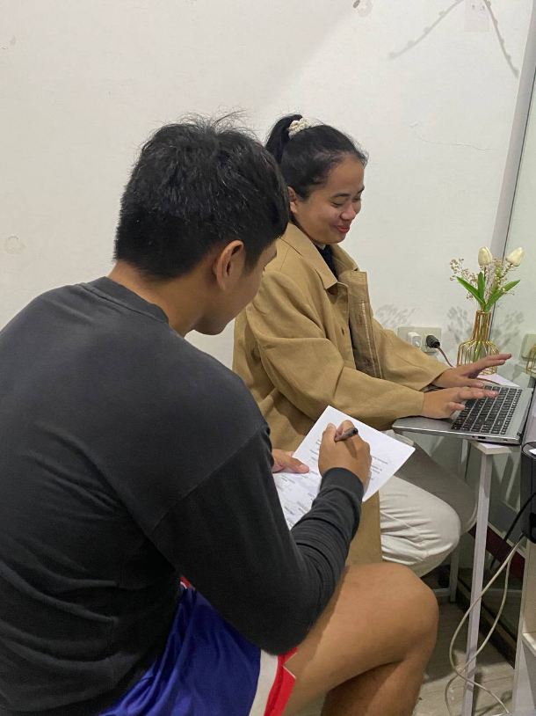

* What’s your company name? JASC.ph Collection
* So how long did JASC.ph operate? "We are proud to say that our business has been in operation for 3 years, since 2020.
* Describe your main products/services? At JASCph, we specialize in providing a wide range of high-quality hair accessories. Our collection includes ribbons, scrunchies, headbands and baby collection carefully curated to cater to diverse styles and preferences. Whether you're looking for everyday essentials or statement pieces for special occasions, we have something for everyone.
* How do you currently market your products/services? By posting in social media like facebook, Instagram and tiktok.
* May I know the list of products of JASC.ph and the price of each product?

**Current Products:**

**Ribbon Category:**

1. Bowtie barette classic size

₱45 each (10cm Barette) ₱39 (Alligator clips 5.5cm)

2. Long Bowtailed barette

₱85 each

3. Sweetheart bowtailed barette

₱99 each

**Newest design for ribbon:**

1. Premium deluxe long ribbon (1/4") ₱39

2. Premium deluxe ribbon (1/2) ₱59

3. Premium deluxe (1") ₱79

4. Premium deluxe Layered ribbon (1") ₱99

**Scrunchies Category:**

XXS scrunchies

XXL scrunchies

**Headbands Category:**

1. Minicrown scrunchies ₱45

2. Multipurpose Twilly ₱35 each

3. Layered bow headband ₱80

**Babycollection Category:**

1. Babybow pair clip ₱45

2. Babybow nylon headbands ₱35

3. Babybow mini pair clip ₱39 (new)

4. Babybow knot headband ₱69 (new)

* So are you agree that we will create a system for your shop? Yes of course, I think that system will helped my shop to gain more sales because there have no existing system for this shop.